Date: ____________
Practical No. 02
Aim: A) Write a python program to obtain a dataset and calculate descriptive statistics (Mean, Median, Mode, Variance, Standard Deviation, Minimum, and Maximum) for a specific variable of interest.
B) Write a python program to create visualizations (histograms, box plots) to depict the distribution of a variable and analyze its characteristics.
A) Write a python program to obtain a dataset and calculate descriptive statistics (Mean, Median, Mode, Variance, Standard Deviation, Minimum, and Maximum) for a specific variable of interest.
Dataset
Student Marks: [45, 50, 55, 60, 65, 70, 75, 80, 85, 90]
INPUT:
import statistics
# Dataset
marks = [45, 50, 55, 60, 65, 70, 75, 80, 85, 90]
# Descriptive Statistics
mean = statistics.mean(marks)
median = statistics.median(marks)
variance = statistics.variance(marks)
std_dev = statistics.stdev(marks)
minimum = min(marks)
maximum = max(marks)
# Mode (handling if no unique mode exists)
try:
mode = statistics.mode(marks)
except:
mode = "No unique mode"
# Display results
print("Mean =", mean)
print("Median =", median)
print("Mode =", mode)
print("Variance =", variance)
print("Standard Deviation =", round(std_dev, 2))
print("Minimum =", minimum)
print("Maximum =", maximum)
OUTPUT:
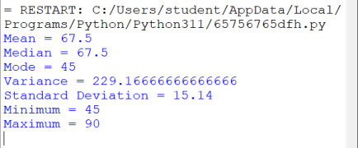
Statistic  Mean  Median  Mode  Variance  Standard  Deviation  Minimum  Maximum | Value | Description  Average of all marks  Middle value of the sorted dataset  Most frequently occurring value (Python returns first value when all are unique)  Measures spread of data from the mean  Square root of variance  Smallest mark  Largest mark
 | 67.5
 | 67.5
 | 45
 | 229.17
 | 15.14
 | 45
 | 90

Conclusion
The average student score is 67.5 marks. The marks are spread around the mean with a standard deviation of 15.14, indicating moderate variability in student performance. The scores range from 45 to 90.
B) Write a python program to create visualizations (histograms, box plots) to depict the distribution of a variable and analyze its characteristics.
Dataset
Employee Monthly Salaries (in ₹):
salaries = [25000, 28000, 30000, 32000, 35000,
38000, 40000, 42000, 45000, 48000,
50000, 52000, 55000, 60000, 65000]
INPUT:
import matplotlib.pyplot as plt
# Employee Salary Dataset
salaries = [25000, 28000, 30000, 32000, 35000,
38000, 40000, 42000, 45000, 48000,
50000, 52000, 55000, 60000, 65000]
# Histogram
plt.figure(figsize=(6,4))
plt.hist(salaries, bins=5)
plt.title("Histogram of Employee Salaries")
plt.xlabel("Salary (₹)")
plt.ylabel("Number of Employees")
plt.show()
# Box Plot
plt.figure(figsize=(6,4))
plt.boxplot(salaries)
plt.title("Box Plot of Employee Salaries")
plt.ylabel("Salary (₹)")
plt.show()
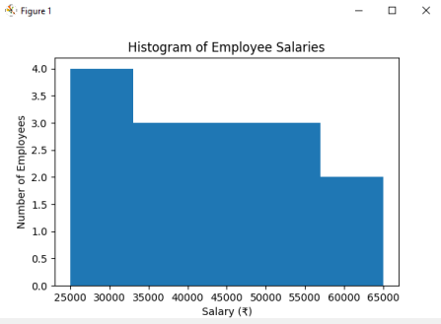
Histogram:
Salary Range (₹) Frequency
25,000–33,000 4
33,001–41,000 3
41,001–49,000 3
49,001–57,000 3
57,001–65,000 2
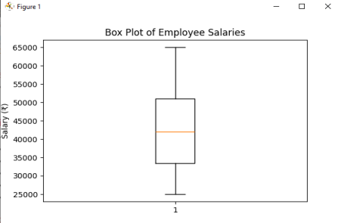Box Plot Summary:
Statistic Value (₹)
Minimum 25,000
Q1 32,000
Median 42,000
Q3 52,000
Maximum 65,000
Outliers None
Analysis
Histogram Analysis
• Most employee salaries are between ₹30,000 and ₹55,000.
• The distribution is fairly balanced.
• Salaries are spread across a wide range from ₹25,000 to ₹65,000.
Box Plot Analysis
• Median salary is ₹42,000, meaning half of employees earn less and half earn more. • The interquartile range (IQR) is ₹20,000, indicating moderate variation. • No extreme outliers are present.
• Salary distribution appears reasonably uniform.
Conclusion
The employee salary data shows a moderate spread with no outliers. Most employees earn between ₹32,000 and ₹52,000, and the median salary of ₹42,000 represents the typical employee income. This analysis helps organizations understand salary distribution and compensation patterns.

